ULTRASONIC TESTING REPORT
Company/Client |  | NCOC N. V. |  | Project |  |  | ESKENE WEST |  | Location |  | Unit 330
Line No/Tag No: |  | Lines around  A1-330-VJ-102  See job desc. and table |  | Material |  |  | A333 Gr.6;  A671 CC60 EFW |  | Día × Nominal Thickness |  | According to table
Procedure No: |  | QP-11-UTT-Q01 Rev 03  GOST 28702-90 |  | Calibration Block |  |  | Step wedge |  | Probe  S/N |  | D798-SM  1209315
 |  |  |  | Calibration block Range |  |  | 5.0-40 mm |  | Angle |  | 0º
Manufacturing Code |  | ASME B31.3 |  | Calibration Temp |  |  | +10; 12ºC |  | Frequency |  | 7.5 MHz
 |  |  |  | Object Temp |  |  | +75; 130ºC |  | Size |  | 8 mm
Acceptance Standard: |  | Acc. to the client specif. |  | Correction factors |  |  | Temperature correction was done |  | Crystal |  | Dual
Surface condition |  | Coated |  | Couplant |  |  | High temperature UT Gel |  | Accuracy |  | ± 0,1 mm
S. No | Equipment/  Material Name |  | Manufacturer |  | Serial No |  |  | Calibration certificate No |  | Calibration Expiry date
 | DL-38 |  | OLYMPUS |  | 171421601 |  |  | BK-01-0674 |  | 05-02-2021
 | Step wedge calibration block |  | Fizpribor |  | 3255-20 |  |  | - |  | -
Job description:
- UT spot check performed on line:
A1-3301-AM-026-4”-A18-WN (KE01-A1-330-PG-P-DI-1065-004)
A1-3301-AM-025-10”-A18-WN (KE01-A1-330-PG-P-DI-1064-004);
A1-3301-AM-369-10”-A18-WN (KE01-A1-330-PG-P-DI-1343-001; 002);
A1-3301-AM-369-18”-A18-WN (KE01-A1-330-PG-P-DI-1343-003);
A1-330-AM-224-6”-A18-WN (KE01-A1-330-PG-P-DI-1219-002)
A1-3301-AM-094-18”-A18-WN (KE01-A1-330-PG-P-DI-1116-009)
A1-3301-AM-025-18”-A18-WN (KE01-A1-330-PG-P-DI-1064-004)
- Echo to echo UT technique was used.
- Inspection performed on East, West, South, North, Top, Bottom and Extrados from external.
- UT thickness has been carried out on locations, which pointed on below drawings, via 100×50 mm rectangle on each item according SoW.
1  2  3  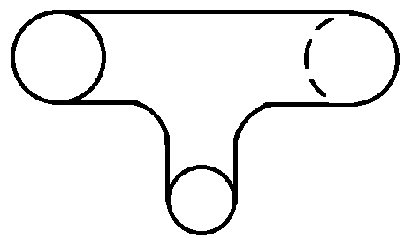  4 |  |  |  |  |  | 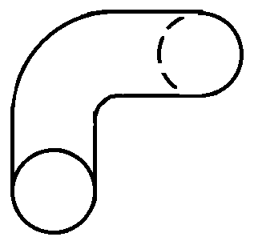  1  2, 3, 4  5
Row. No
50 mm
Column No
R3
R2
R1/C1 | C2 | C3 | C4
100 mm
Notes:
N/A – not applicable.

Inspection drawing
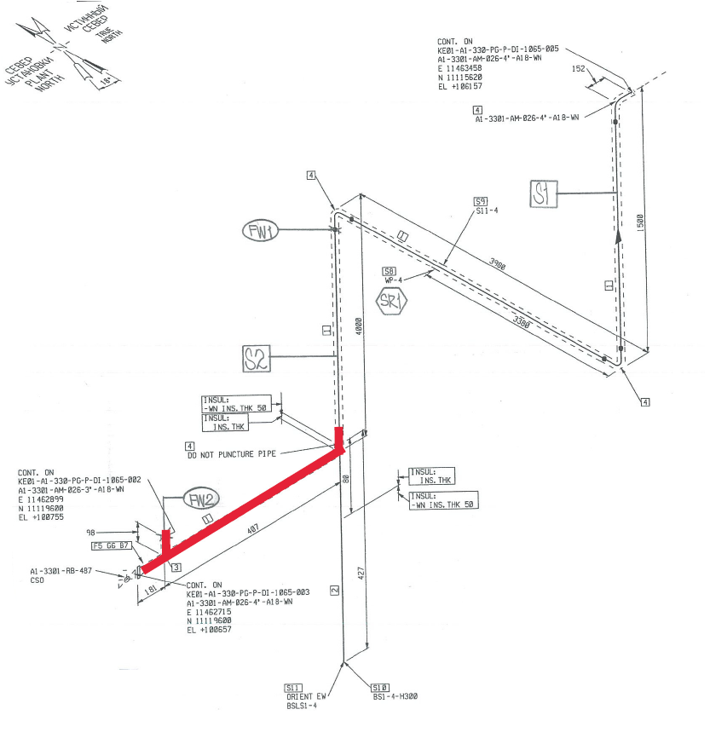
Elbow-03
Pipe-02
Tee-01
A1-3301-AM-026-4”-A18-WN (KE01-A1-330-PG-P-DI-1065-004)

Inspection results
P&ID | Isometric No | Line No | Item description | Spot Check | DIA(Ø), inch | Nominal thickness, mm | East  mm | West  mm | South  mm | North  mm | Top  mm | Bottom  mm | Extrados  mm
KE01-A1-330-PG-R-HP-0010-032 | KE01-A1-330-PG-P-DI-1065-004 | A1-3301-AM-026-4”-A18-WN | Tee-01 | 1 | 4×3 | 6.02×5.49 | - | - | 7.67 | 7.52 | 7.05 | 8.59 | -
 |  |  |  | 2 | 4×3 | 6.02×5.49 | - | - | 8.78 | 8.62 | - | 9.08 | -
 |  |  |  | 3 | 4×3 | 6.02×5.49 | - | - | 7.75 | 7.80 | 7.28 | 8.74 | -
 |  |  |  | 4 | 4×3 | 6.02×5.49 | - | - | 5.74 | 5.75 | - | - | -
KE01-A1-330-PG-R-HP-0010-032 | KE01-A1-330-PG-P-DI-1065-004 | A1-3301-AM-026-4”-A18-WN | Pipe-02 | 1 | 4 | 6.02 | - | - | 6.35 | 5.38 | 6.42 | 5.45 | -
KE01-A1-330-PG-R-HP-0010-032 | KE01-A1-330-PG-P-DI-1065-004 | A1-3301-AM-026-4”-A18-WN | Elbow-03 | 1 | 4 | 6.02 | - | - | 5.61 | 6.28 | - | - | 5.80

Inspection drawing
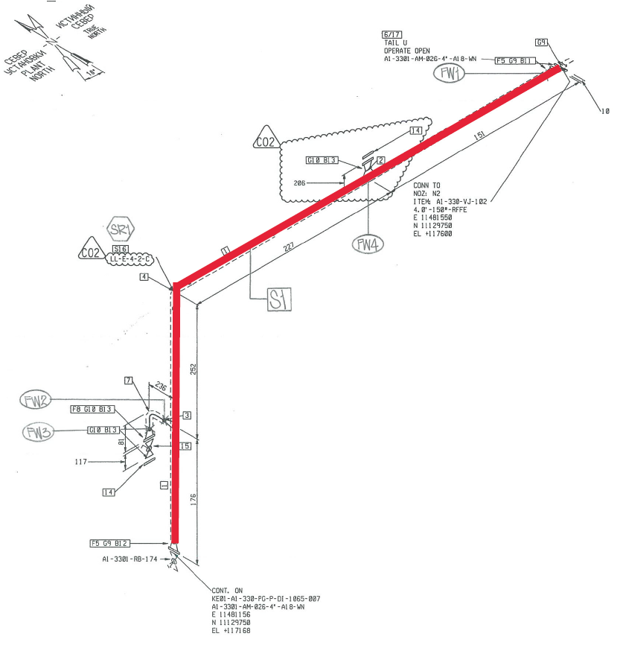
Elbow-02
Pipe-01
Pipe-03
A1-3301-AM-026-4”-A18-WN (KE01-A1-330-PG-P-DI-1065-004)

Inspection results
P&ID | Isometric No | Line No | Item description | Spot Check | DIA(Ø), inch | Nominal thickness, mm | East  mm | West  mm | South  mm | North  mm | Top  mm | Bottom  mm | Extrados  mm
KE01-A1-330-PG-R-HP-0010-032 | KE01-A1-330-PG-P-DI-1065-004 | A1-3301-AM-026-4”-A18-WN | Pipe-01 | 1 | 4 | 6.02 | - | - | 5.30 | 5.24 | 5.74 | 5.40 | -
KE01-A1-330-PG-R-HP-0010-032 | KE01-A1-330-PG-P-DI-1065-004 | A1-3301-AM-026-4”-A18-WN | Elbow-02 | 1 | 4 | 6.02 | - | - | 5.89 | 5.78 | - | - | 5.50
KE01-A1-330-PG-R-HP-0010-032 | KE01-A1-330-PG-P-DI-1065-004 | A1-3301-AM-026-4”-A18-WN | Pipe-03 | 1 | 4 | 6.02 | 5.44 | 5.69 | 5.54 | 5.63 | - | - | -

Inspection drawing
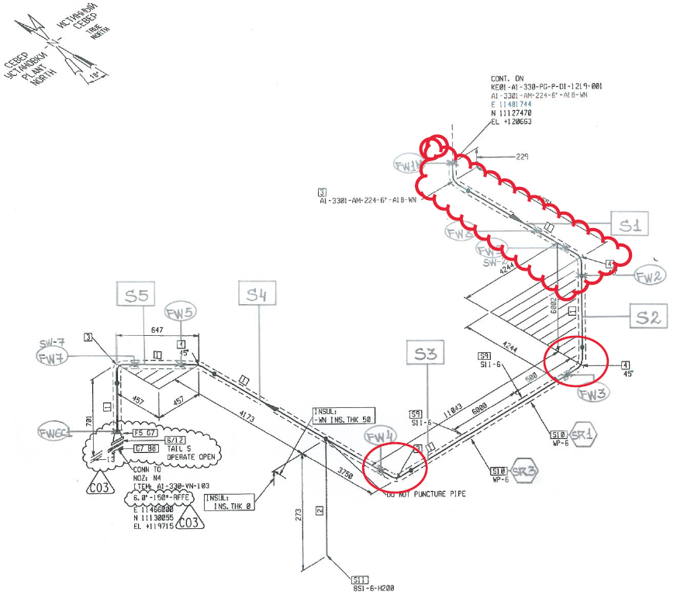
Elbow-01
Elbow-02
A1-330-AM-224-6”-A18-WN (KE01-A1-330-PG-P-DI-1219-002)

Inspection results
P&ID | Isometric No | Line No | Item description | Spot Check | DIA(Ø), inch | Nominal thickness, mm | East  mm | West  mm | South  mm | North  mm | Top  mm | Bottom  mm | Extrados  mm
KE01-A1-330-PG-R-HP-0010-031 | KE01-A1-330-PG-P-DI-1219-002 | A1-330-AM-224-6”-A18-WN | Elbow-01 | 1 | 6 | 7.11 | - | - | - | - | 7.91 | 7.87 | 7.57
KE01-A1-330-PG-R-HP-0010-031 | KE01-A1-330-PG-P-DI-1219-002 | A1-330-AM-224-6”-A18-WN | Elbow-02 | 1 | 6 | 7.11 | - | - | - | - | 9.22 | 9.68 | 8.88

Inspection drawing
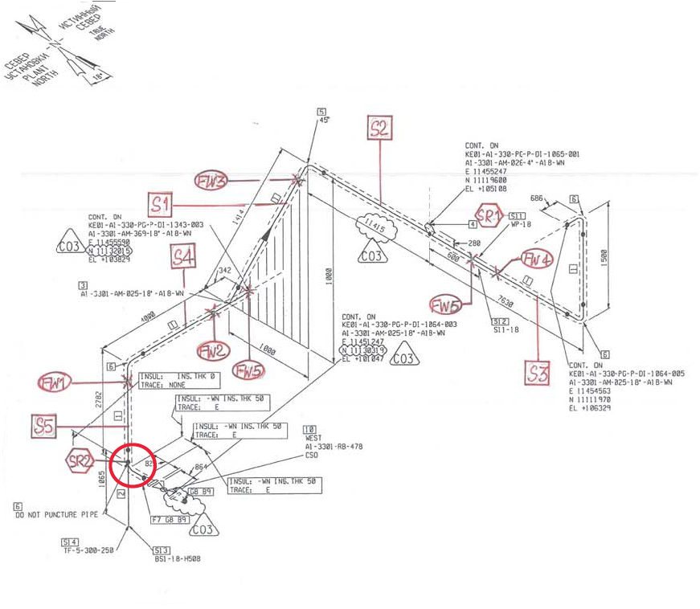
Elbow-01
A1-3301-AM-025-18”-A18-WN (KE01-A1-330-PG-R-HP-0010-032/ KE01-A1-330-PG-P-DI-1064-004)

Inspection Results, mm
Item description | DIA(Ø) × Nominal Thickness, mm | Row No | Column No
Item description | DIA(Ø) × Nominal Thickness, mm | Row No | C1 | C2 | C3 | C4 | C5 | C6 | C7 | C8 | C9 | C10 | C11 | C12 | C13 | C14
Elbow-01 | 18”×9.52 | 1 | 10.41 | 9.74 | 9.67 | 10.75 | 10.89 | 10.63 | 9.47 | 9.65 | 10.11 | 9.78 | 9.96 | 10.72 | 10.83 | 9.86
Elbow-01 | 18”×9.52 | 2 | 9.60 | 10.78 | 9.69 | 10.05 | 9.89 | 9.87 | 10.32 | 10.23 | 10.44 | 10.78 | 10.78 | - | - | -
Elbow-01 | 18”×9.52 | 3 | 9.72 | 10.90 | 9.85 | 10.15 | 9.84 | 9.97 | 10.15 | 10.40 | 10.58 | 10.82 | 10.87 | - | - | -
Elbow-01 | 18”×9.52 | 4 | 9.70 | 10.85 | 10.63 | 9.99 | 9.71 | 9.84 | 10.34 | 10.22 | 10.40 | 10.87 | 10.86 | - | - | -
Elbow-01 | 18”×9.52 | 5 | 9.76 | 9.43 | 9.68 | 10.88 | 10.31 | 9.89 | 9.57 | 9.79 | 9.89 | 10.08 | 10.29 | 11.02 | 10.70 | 9.70

Inspection drawing
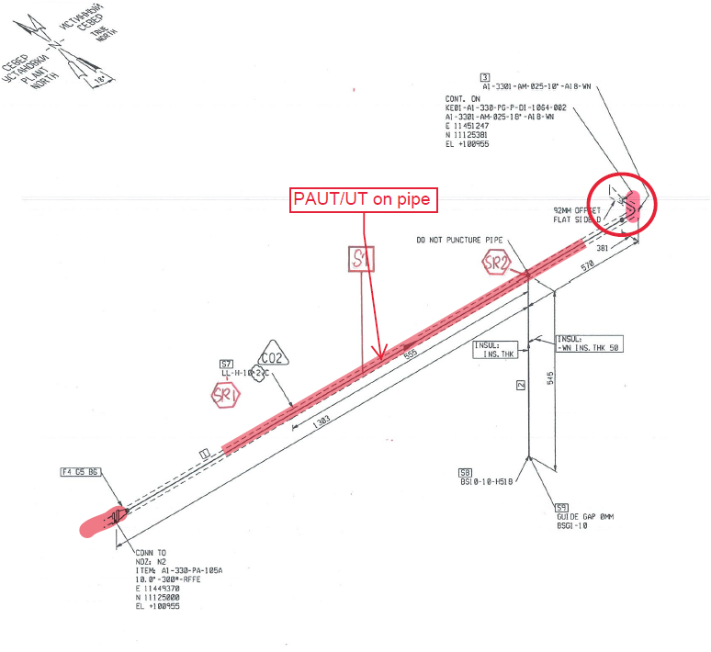
Elbow-01
Nozzles-N2
(A1-330-105A)
See report PAUT
04-YKR-ON-PAUT-20-148
A1-3301-AM-025-10”-A18-WN (KE01-A1-330-PG-R-HP-0010-032/ KE01-A1-330-PG-P-DI-1064-001)

Inspection Results, mm
Item description | DIA(Ø) × Nominal Thickness, mm | Row No | Column No
Item description | DIA(Ø) × Nominal Thickness, mm | Row No | C1 | C2 | C3 | C4 | C5 | C6 | C7 | C8 | C9
Elbow-01 | 10”x9.27 | 1 | 8.58 | 8.59 | 8.64 | 8.04 | 8.71 | 8.62 | 8.59 | 8.59 | 8.58
Elbow-01 | 10”x9.27 | 2 | 8.49 | 9.00 | 8.69 | 8.78 | 8.88 | 8.74 | 8.76 | 8.53 | 8.71
Elbow-01 | 10”x9.27 | 3 | 8.39 | 8.86 | 8.62 | 8.71 | 8.78 | 8.70 | 8.87 | 8.52 | 8.83
Elbow-01 | 10”x9.27 | 4 | 8.37 | 9.01 | 8.68 | 8.65 | 8.89 | 8.60 | 8.70 | 8.51 | 8.75
Elbow-01 | 10”x9.27 | 5 | 8.29 | 8.39 | 8.49 | 8.50 | 8.86 | 8.30 | 8.90 | 8.49 | 8.68

Item description | DIA(Ø), inch | Nominal thickness, mm | Spot  check | Top  mm | Bottom  mm | North  mm | South  mm | East  mm | West  mm | Intrados  mm | Extrados  mm
Nozzles-N2  A1-330-105A | 10” | No info¹ | 1 | 8.34 | 14.19 | 7.07 | 12.73 | - | - | - | -
Notes:
- Information regarding thickness of the nozzle is absent in SAP documentation. Passport was not found. Nozzle N2 is part of pump shell (casting).

Inspection drawing
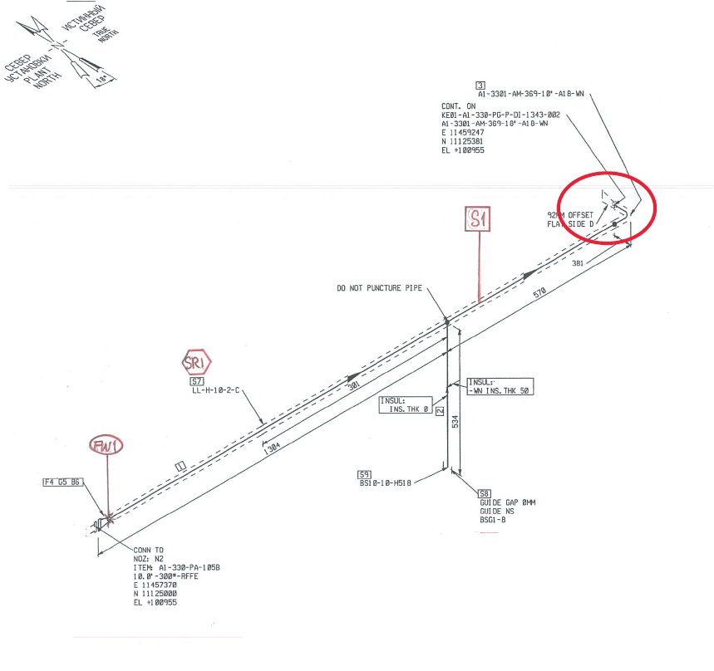
Elbow-01
Nozzles-N2
(A1-330-105B)
Pipe-01
A1-3301-AM-369-10”-A18-WN (KE01-A1-330-PG-R-HP-0010-032/ KE01-A1-330-PG-P-DI-1343-001)

Inspection Results, mm
Item description | DIA(Ø) × Nominal Thickness, mm | Row No | Column No
Item description | DIA(Ø) × Nominal Thickness, mm | Row No | C1 | C2 | C3 | C4 | C5 | C6 | C7 | C8 | C9
Elbow-01 | 10”x9.27mm | 1 | 8.53 | 8.41 | 8.63 | 8.70 | 8.51 | 8.62 | 8.71 | 8.45 | 8.79
Elbow-01 | 10”x9.27mm | 2 | 8.98 | 8.41 | 8.62 | 8.67 | 8.75 | 8.97 | 9.28 | 8.65 | 8.47
Elbow-01 | 10”x9.27mm | 3 | 9.07 | 8.69 | 8.68 | 8.76 | 8.86 | 9.00 | 9.17 | 8.67 | 8.81
Elbow-01 | 10”x9.27mm | 4 | 9.01 | 8.58 | 8.76 | 8.01 | 8.89 | 9.11 | 9.09 | 8.68 | 9.01
Elbow-01 | 10”x9.27mm | 5 | 8.75 | 8.24 | 8.61 | 8.93 | 9.02 | 9.18 | 9.23 | 8.91 | 8.70

Item description | DIA(Ø), inch | Nominal thickness, mm* | Spot  check | Top  mm | Bottom  mm | North  mm | South  mm | East  mm | West  mm | Intrados  mm | Extrados  mm
Nozzles-N2  A1-330-105B | 10” | N/A | 1 | 8.29 | 13.17 | 7.07 | 12.73 | - | - | - | -
Pipe-01 | 10” | 9.27mm | 1 | 9.78 | 9.46 | 9.94 | 9.50 | - | - | - | -
Pipe-01 | 10” | 9.27mm | 2 | 9.85 | 9.36 | 9.32 | 9.52 | - | - | - | -
Pipe-01 | 10” | 9.27mm | 3 | 9.99 | 9.27 | 9.42 | 9.60 | - | - | - | -
Pipe-01 | 10” | 9.27mm | 4 | 9.81 | 9.27 | 9.49 | 9.66 | - | - | - | -
Pipe-01 | 10” | 9.27mm | 5 | 9.91 | 9.80 | 9.44 | 9.97 | - | - | - | -
Pipe-01 | 10” | 9.27mm | 6 | 9.86 | 9.48 | 9.45 | 9.69 | - | - | - | -
Notes:
- Information regarding thickness of the nozzle is absent in SAP documentation. Passport was not found. Nozzle N2 is part of pump shell (casting).

Inspection drawing
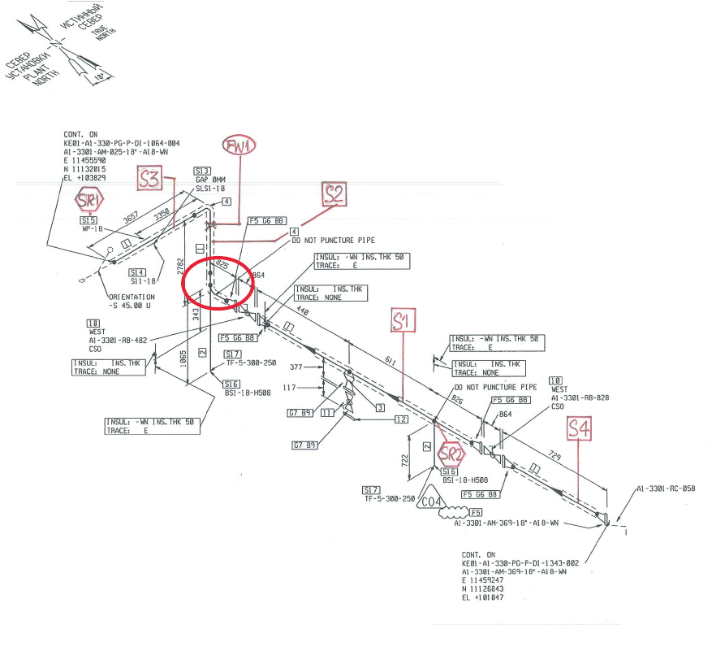
Elbow-01
Pipe-02
A1-3301-AM-369-18”-A18-WN (KE01-A1-330-PG-R-HP-0010-032/ KE01-A1-330-PG-P-DI-1343-003)

Inspection Results, mm
Item description | DIA(Ø) × Nominal Thickness, mm | Row No | Column No
Item description | DIA(Ø) × Nominal Thickness, mm | Row No | C1 | C2 | C3 | C4 | C5 | C6 | C7 | C8 | C9 | C10 | C11 | C12 | C13 | C14
Elbow-01 | 18”×9.52mm | 1 | 10.02 | 9.72 | 10.57 | 10.15 | 10.00 | 9.87 | 10.11 | 10.01 | 9.76 | 10.31 | 11.03 | 10.70 | 9.86 | 9.93
Elbow-01 | 18”×9.52mm | 2 | 10.60 | 10.30 | 10.17 | 10.12 | 9.82 | 10.17 | 9.86 | 10.57 | 10.86 | 10.61 | 10.14 | - | - | -
Elbow-01 | 18”×9.52mm | 3 | 10.58 | 10.22 | 10.13 | 10.07 | 9.81 | 10.12 | 9.73 | 10.51 | 10.88 | 10.59 | 10.03 | - | - | -
Elbow-01 | 18”×9.52mm | 4 | 10.05 | 10.19 | 10.12 | 10.04 | 9.82 | 10.19 | 9.89 | 10.29 | 10.89 | 10.56 | 10.01 | - | - | -
Elbow-01 | 18”×9.52mm | 5 | 9.40 | 9.78 | 10.31 | 9.51 | 9.70 | 9.79 | 9.96 | 10.38 | 10.00 | 10.39 | 10.91 | 10.58 | 9.98 | 9.61

Item description | DIA(Ø) × Nominal Thickness, mm | Row No | Top, mm | Top-East, mm | East, mm | East-Bot. , mm | Bottom, mm | Bot.-West, mm | West, mm | West-Top, mm
Pipe-02 | 18”×9.52 | 1 | 9.95 | 10.80 | 10.06 | 10.51 | 11.09 | 10.20 | 10.28 | 9.88
Pipe-02 | 18”×9.52 | 2 | 10.00 | 10.20 | 9.99 | 10.62 | 11.01 | 9.88 | 10.30 | 9.40
Pipe-02 | 18”×9.52 | 3 | 10.76 | 9.81 | 10.08 | 9.90 | 10.89 | 9.80 | 9.83 | 9.36
Pipe-02 | 18”×9.52 | 4 | 9.83 | 9.94 | 9.98 | 10.41 | 10.80 | 9.80 | 9.76 | 9.90
Pipe-02 | 18”×9.52 | 5 | 9.99 | 10.53 | 10.16 | 10.37 | 10.35 | 10.12 | 10.25 | 9.80
Reducer-03 | 18”×9.52mm/ 10”×9.27mm | 1 | 24.32 | 24.07 | 21.17 | 15.48 | 15.48 | 24.95 | 20.34 | 16.43
Reducer-03 | 18”×9.52mm/ 10”×9.27mm | 2 | 24.02 | 24.12 | 21.36 | 16.32 | 15.32 | 23.38 | 20.63 | 16.00
Reducer-03 | 18”×9.52mm/ 10”×9.27mm | 3 | 20.36 | 21.15 | 19.19 | 16.72 | 15.71 | 20.93 | 19.42 | 16.79
Reducer-03 | 18”×9.52mm/ 10”×9.27mm | 4 | 17.01 | 17.21 | 14.07 | 14.31 | 14.35 | 16.21 | 14.89 | 14.80
Reducer-03 | 18”×9.52mm/ 10”×9.27mm | 5 | 14.11 | 13.63 | 13.24 | 13.26 | 13.19 | 13.76 | 13.26 | 13.26

Inspection drawing
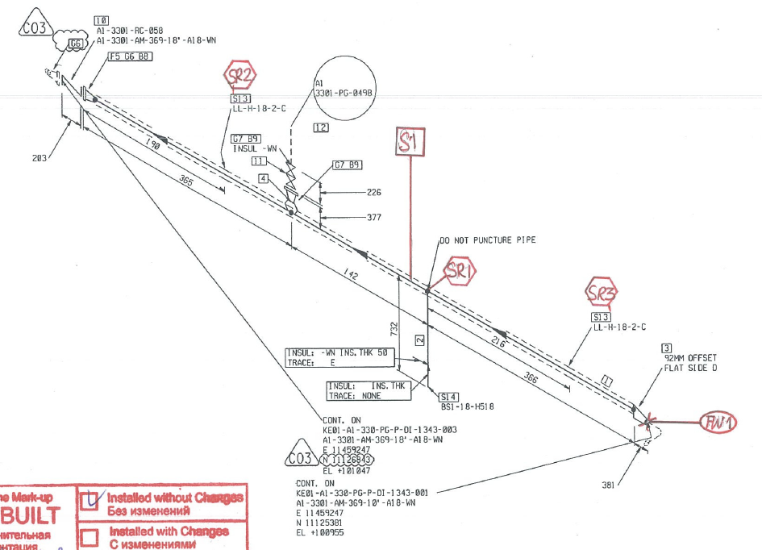
Reducer-03
A1-3301-AM-369-18”-A18-WN (KE01-A1-330-PG-R-HP-0010-032/ KE01-A1-330-PG-P-DI-1343-002)

Item description | DIA(Ø) × Nominal Thickness, mm | Row No | Top, mm | Top-East, mm | East, mm | East-Bot. , mm | Bottom, mm | Bot.-West, mm | West, mm | West-Top, mm
Reducer-03 | 18”×9.52mm/ 10”×9.27mm | 1 | 24.32 | 24.07 | 21.17 | 15.48 | 15.48 | 24.95 | 20.34 | 16.43
Reducer-03 | 18”×9.52mm/ 10”×9.27mm | 2 | 24.02 | 24.12 | 21.36 | 16.32 | 15.32 | 23.38 | 20.63 | 16.00
Reducer-03 | 18”×9.52mm/ 10”×9.27mm | 3 | 20.36 | 21.15 | 19.19 | 16.72 | 15.71 | 20.93 | 19.42 | 16.79
Reducer-03 | 18”×9.52mm/ 10”×9.27mm | 4 | 17.01 | 17.21 | 14.07 | 14.31 | 14.35 | 16.21 | 14.89 | 14.80
Reducer-03 | 18”×9.52mm/ 10”×9.27mm | 5 | 14.11 | 13.63 | 13.24 | 13.26 | 13.19 | 13.76 | 13.26 | 13.26

Examined by:  UT L II cert. No. 63-05-19  expire date: 28.05.2022 | Name: Zhuravlyov Sergey | Signature: ............................... | Date: 10 November 2020
Approved by  UT L III cert.2B 034/20  expire date 28.02.2025 | Name: Shundryk Ihar | Signature: ............................ | Date: 10 November 2020
Client Representative: | Name: …………………………… | Signature: .............................. | Date: ……………………

